# An Extensible Induced Position Encoding Readout Method for Micro-pattern Gas Detectors [1]

ShuBin Liu1,2 Binxiang Qi1.2 Siyuan Ma1,2 Zhongtao Shen 1,2 Guangyuan Yuan1,2 Qi An1,2

1 State Key Laboratory of Particle Detection and Electronics, University of Science and Technology of China, Hefei 230026, China

2 Department of Modern Physics, University of Science and Technology of China, Hefei 230026, China

**Abstract**: The requirement of a large number of electronics channels has become an issue to the further applications of Micro-pattern Gas Detectors (MPGDs), and poses a big challenge for the integration, power consumption, cooling and cost. Induced position encoding readout technique provides an attractive way to significantly reduce the number of readout channels. In this paper, we present an extensible induced position encoding readout method for MPGDs. The method is demonstrated by the Eulerian path of graph theory. A standard encoding rule is provided, and a general formula of encoding & decoding for n channels is derived. Under the premise of such method, a one-dimensional induced position encoding readout prototyping board is designed on a 5×5 cm2 Thick Gas Electron Multiplier (THGEM), where 47 anode strips are read out by 15 encoded multiplexing channels. Verification tests are carried out on a 8 keV Cu X-ray source with 100μm slit. The [test](javascript:void(0);) results show a robust feasibility of the method, and have a good spatial resolution and linearity in its position response. The method can dramatically reduce the number of readout channels, and has potential to build large area detectors and can be easily adapted to other detectors like MPGDs.

**Key words:** micro-pattern gas detector, position encoding, multiplexing readout, tracking

1. **Introduction**

Over the past 20 years, Micro-pattern Gas Detectors (MPGDs) are widely used in high-energy physics, and have expanded to astrophysics, nuclear physics and medical imaging.[1][2] The conventional readout techniques employ a large number of electronic channels, which poses a big challenge to the further applications of MPGDs. By changing the readout electrode’s structure and multiplexing the readout channels, an induced position encoding technique for micro-channel plate detector was developed by D. Kataria et al. [3] in 2007. The technique was used for MPGDs by R. Hu et al. in 2011 [4], where a preliminary feasibility test was implemented with Micromegas. This technique can significantly reduce the number of readout channels, but the foregoing works didn’t provide an extensible encoding method and the decoding is complicated. In this paper, an extensible induced position encoding readout method for MPGDs is presented. The method is demonstrated by the Eulerian path of graph theory. A standard encoding rule is provided, and a general formula of encoding & decoding for *n* channels is derived. A prototyping design is implemented on a 5×5 cm2 Thick GEM, and verification tests are carried out on a 8 keV Cu X-ray source with 100μm slit.

1. **Principle and Method**
   1. **Principle**

The simplified schematic is shown in Fig.1, where 6 strips are readout by 3 encoded multiplexing channels. Charge from detectors is collected by an anode strip and split across two induced strips which correspond to the respective readout channels. Due to the different width, charge is split unequally between the two induced strips, where the amplitude on one always higher than on the other. Based on the signal’s amplitude in corresponding channel, the hit position could be uniquely decoded as seen in Table 1.

|  |  |
| --- | --- |
| Channel: comparsion | Strip: position |
| CH1>CH2 | Strip 1 |
| CH2>CH3 | Strip 2 |
| CH3>CH1 | Strip 3 |
| CH1>CH3 | Strip 4 |
| CH3>CH2 | Strip 5 |
| CH2>CH1 | Strip 6 |



Fig. 1. Induced position encoding readout schematic Table 1 Decoding table of 3 readout channels

* 1. **Eulerian Path** [**Theorem**](javascript:void(0);)

As shown in Fig.1, 3 readout channels have ordered doublets combinations{12,23,31,13,32,21}which corresponds to 6 anode strips. The technique requires that any ordered doublets combination of channels appeared exactly once, and formed head to tail as an encoding list. Generally, the principle described above is a graph theory problem that whether there is an Eulerian path, where the doublet combinations represent the edges and the readout channels represent the vertices. Fig. 2 shows an Eulerian pathof the 3 readout channels in Fig.1. According to Eulerian path theorem [5], it can be proved that there is an Eulerian path for n channels induced position encoding readout, as all of its vertices have an even degree. In other words, *n* channels can encode readout a maximum anode strips.

* 1. **Encoding and Decoding**

It turns out that there are more than one constructions of Eulerian path. We need to make appropriate constraints to construct a regular and extensible encoding method so as to easily decode and design. As shown in Table 2, it is an extensible encoding list for n channels, where the list is organized in rows. The encoding form *XY* means that the signal’s amplitude of channel *X* is higher than channel *Y*’s.

|  |  |  |  |  |  |  |  |  |  |  |  |
| --- | --- | --- | --- | --- | --- | --- | --- | --- | --- | --- | --- |
| Row | Encoding list | | | | | | | | | | |
| 1 | 12 | 21 |  |  |  |  |  |  |  |  |  |
| 2 | 13 | 32 | 23 | 31 |  |  |  |  |  |  |  |
| 3 | 14 | 42 | 24 | 43 | 34 | 41 |  |  |  |  |  |
| . |  |  |  |  |  |  |  |  |  |  |  |
| *k-1* | *1k* | *k2* | *2k* | *k3* | *3k* | *k4* | *…* | *k(k-1)* | *(k-1)k* | *k1* |  |
|  |  |  |  |  |  |  |  |  |  |  |  |
| *n-1* | *1n* | *n2* | *2n* | *n3* | *3n* | *n4* |  |  | *n(n-1)* | *(n-1)n* | *n1* |

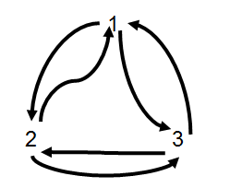

Fig.2 An Eulerian path Table 2. The encoding list of *n* readout channels

According to the Table 2, the encoding formula (1) and decoding formula (2) can be derived as follows:

1. **Verification Test**

In order to verify this method, a prototyping readout board was manufactured and equipped for a 5×5 cm2 THGEM detector[6]. To solve the case that each particle usually showers the signal on several neighboring strips, the neighboring strips are separated into three groups to encode respectively. Based on the encoding list shown in Table 2, the prototyping board has 47 [one-dimensional](javascript:void(0);) 1.07mm strips which readout by 15 channels. According to the decoding formula, the hit strip can be decoded by the fired channels.

As shown in Fig.3, verification tests were carried out on the THGEM detector using a 8 keV Cu X-ray and Ar/iC4H10 (97:3) gas mixture. A 100 μm [slit](javascript:void(0);) in a thin brass sheet was used to produce a miniaturized X-ray beam. A manual movable platform was used for the postion scanning test.The electronics is based on the VATA160 chip.[7]

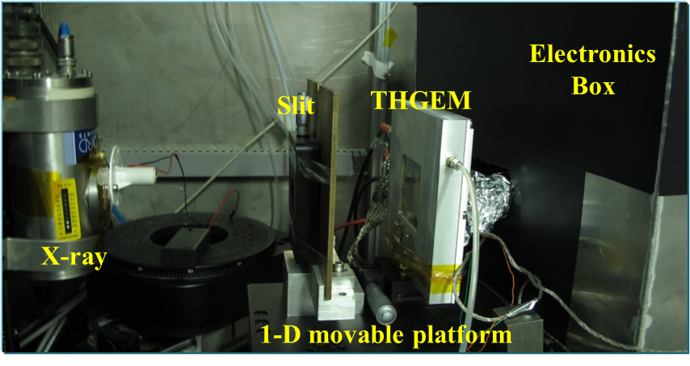

Fig. 3. Experimental setup

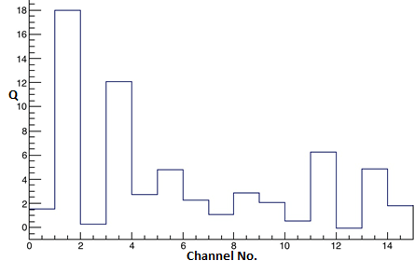 

Fig. 4. The signal recorded on 15 channels when an event hit… Fig. 5. Spatial resolution result of the detector

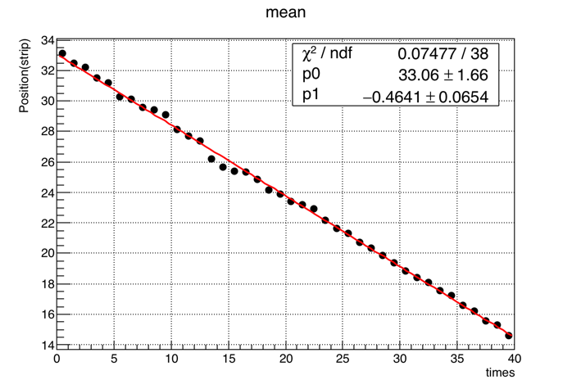 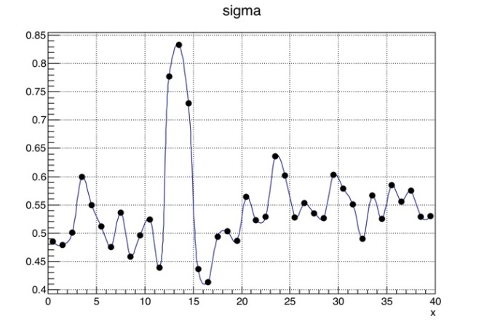

Fig. 6. Linear result of position scanning test. Fig. 7. Spatial resolution results of position scanning test

Fig. 4 shows the signals recorded on all 15 channels when an event hit. Considering the noise of electronics is about 7fC, the channel 2 and 4 are valid, and it can correctly to decode the hit position by the encoding form (24). Fig. 5 shows the decoded spatial resolution result of the detector is 0.4 strip (0.43mm). During the position scanning test, the detector was moved with a step size of 0.5 mm in a 20 mm range. Fig. 6 and Fig. 7 show the results of linearity and spatial resolution in the position scanning test.

1. **Conclusion**

A novel method of encoded multiplexing readout for micro-pattern gas detectors is presented in this work. The method is demonstrated by the Eulerian path of graph theory. A standard rules for encoding is provided, and general formulas of encoding & decoding for n channels are derived. Under the premise of such rules, a one-dimensional position encoding readout circuit boards is designed based on a 5×5 cm2 THGEM，and a verification test is carried out on a 8 keV Cu X-ray source with 100μm slit. The test results indicate that the method can correctly decode the hit position, and have a good spatial resolution and linearity in its position response. The method provides an attractive way to significantly reduce the number of readout channels.Inevitably, the method has some [disadvantage](javascript:void(0);)s, such as lowering the signal to noise ratio (SNR) and lowering the detector’s rate capability.

## References

1. M. Titov, et al., Nucl. Instr. Meth. A, **581**: 25 (2007)
2. Q. Liu, et al., Journal of Instrumentation, **8 (11):** C11008 (2013)
3. D. Kataria, et al., Nucl. Instr. Meth. A, **573**:240 (2007)
4. R. Hu, et al., Nuclear Physics Review, **28(4)**: 459 (2011)
5. J. Gross, et al., Graph theory and its applications. CRC press, (2005)
6. H. Liu, et al. Journal of Instrumentation , **7 (06):** C06001 (2012)
7. VATA160 datasheet, IDEAS, Nydalen, Oslo, Norway, 2013. <http://www.ideas.no>.

1. * Supported by National Natural Science Foundation of China (Grant No.11222552)

   1) E-mail: liushb@ustc.edu.cn (corresponding author)

   2) E-mail: qibx@mail.ustc.edu.cn